**GRAMMAR FIXES**

1. Misplaced comma - “After you sell domestically [insert comma], you may…”

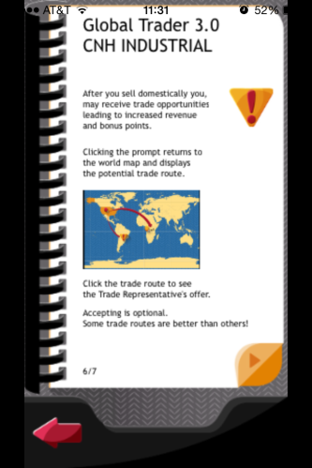

1. Possibly add” (3 seconds)” after “3 weeks.” In order to further reinforce that each second is a week.

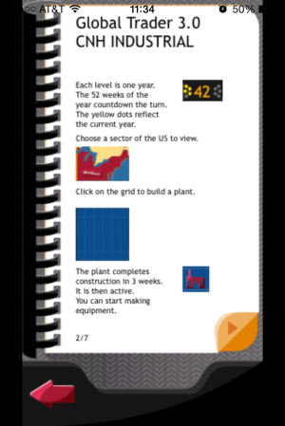

1. Grammar error; currently says "The wrench takes you a list of the plant's Tractor and Skid Steer Models" [forgot the word "to" after the word "you". Screen shots could also increase in size. She caught this one and already passed along

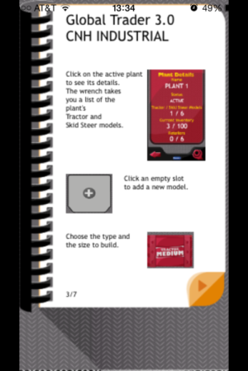

1. On page 5 of the directions there is information about the prompt you will receive from Regional Representatives.  On this page, however, it does not specify where the prompt will come from on the screen.  While playing the game, it took me a minute to figure that out.  Maybe add some information to look for an envelope in the top left corner of the screen?

Regional representative should be changed, “you will be prompted to sell your equipment through a Dealer.”

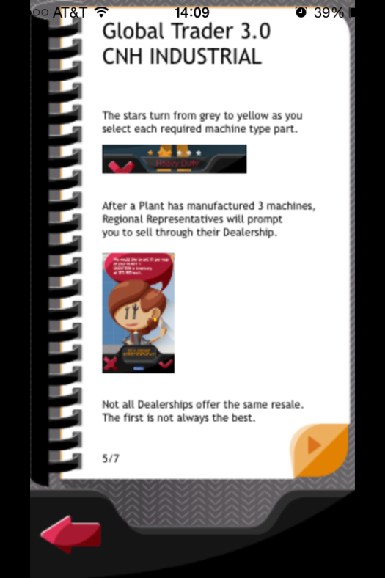

1. Grammar error; "Keep track of your bank the turn time, and the bonus points in the top dashboard." Either should be "your bank's turn time" or "your bank, the turn time". Note taken

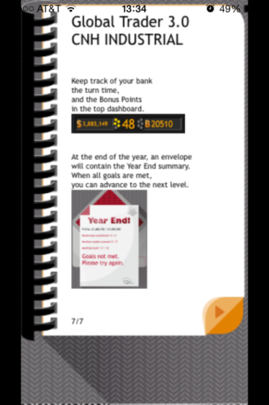

1. Grammar error; "This is the world map. Click on a US Sector icon. to see to a detailed view of the area." should be "This is the world map. Click on a US Sector icon to see a detailed view of the area." It is just the period after word icon, is a prompt outside the tutorial.
2. Regional Representative and Dealership changed to Dealer

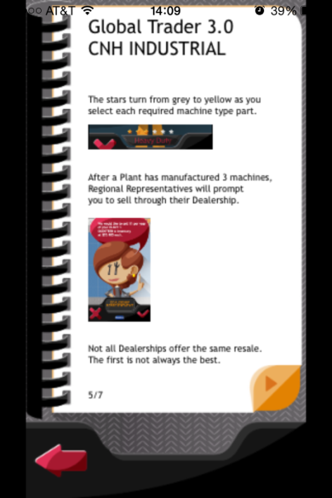

1. Text “to” cut off in text box



1. “opportunities” is spelled incorrectly

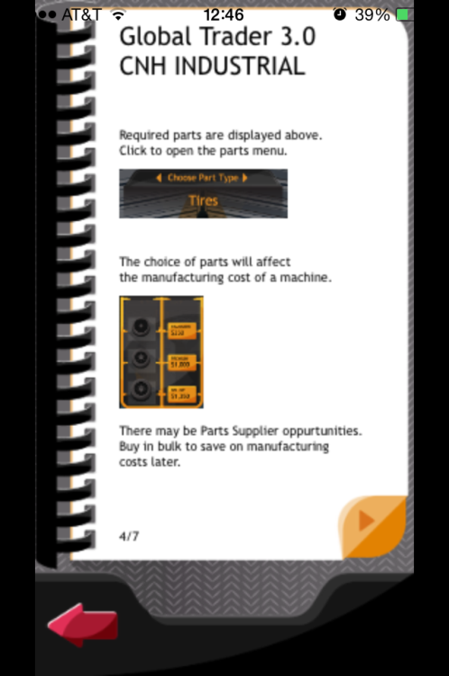

1. Should add “offer” to “the first OFFER is not always the best.”

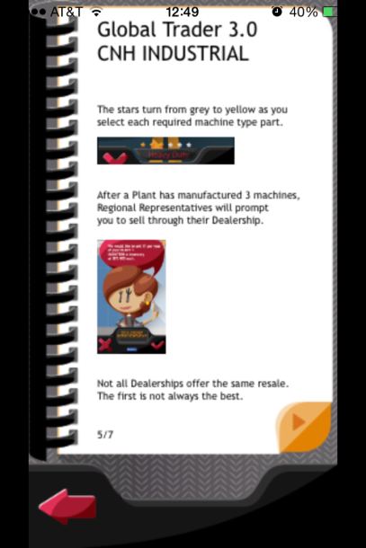

1. Add “you” to “Clicking the prompt returns YOU to the world map and displays the potential trade route.”

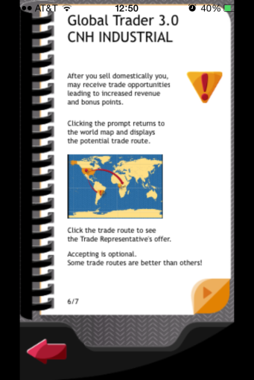

1. Remove period and Remove second “to” in “Click on a US Sector icon. **t**o see a detailed view of the area.”

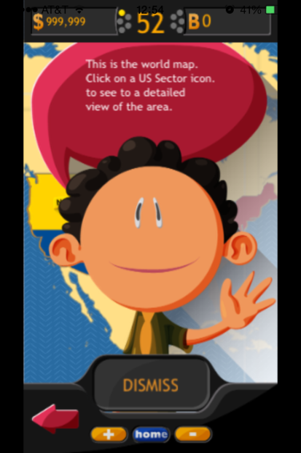

1. Change dealerships

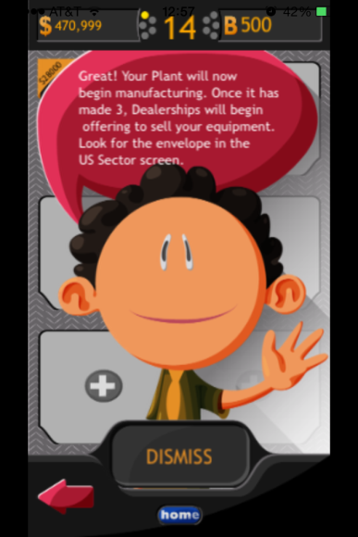

1. Change dealerships

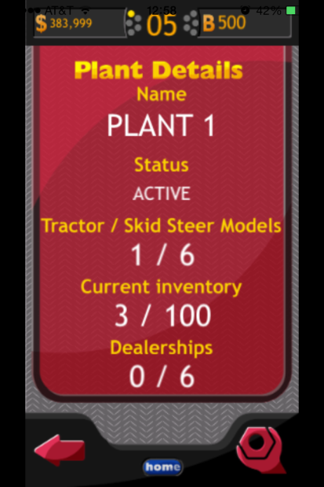

1. Change dealerships

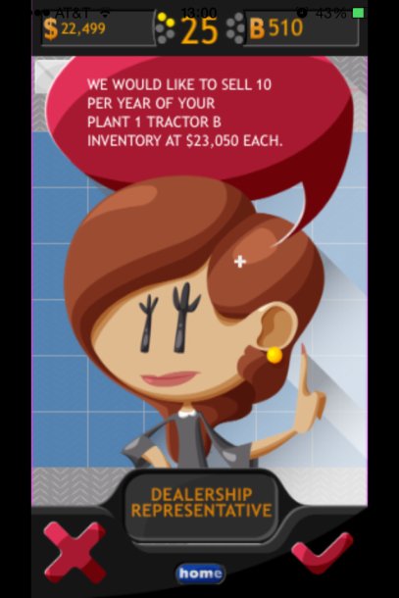

1. Change Dealerships

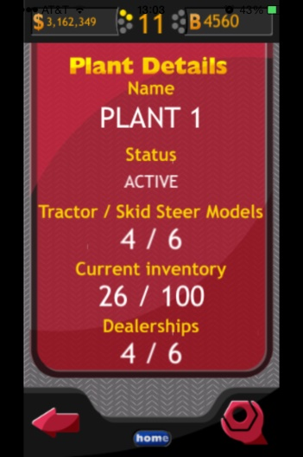

1. Change dealerships

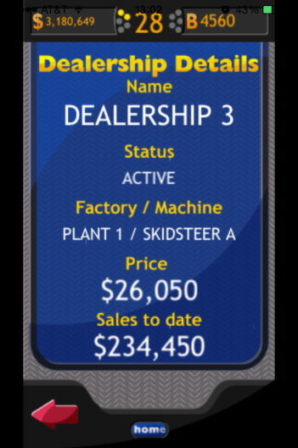

1. Text is being cut off in the Year End Summary portion. (this is consistent through many years.

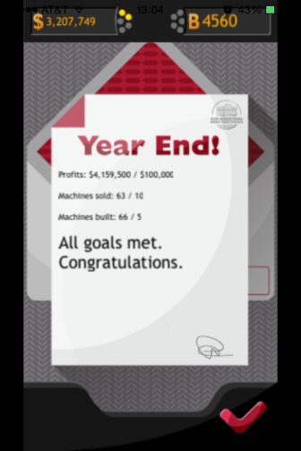

1. Change “as” to “at a” in “Suppliers will now begin to offer you parts AT A discount for bulk orders.”

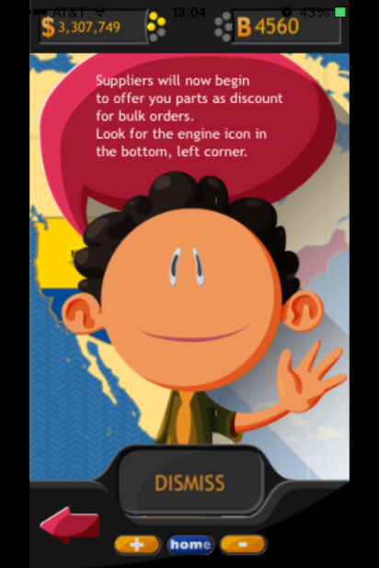

1. Change Dealerships

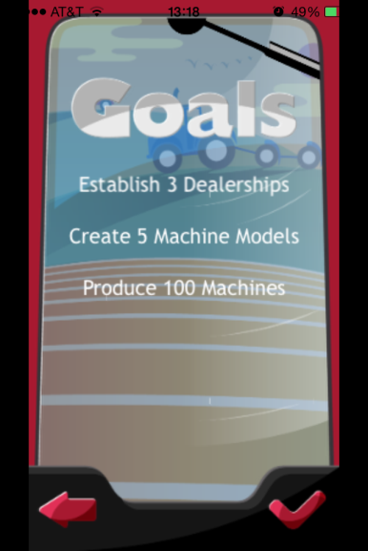

1. Change Dealerships in Year End Summary

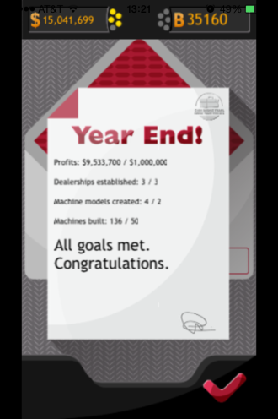

1. “TradeRoute” needs a space in between the two words. Consistent over all regions.

